**Ahsanullah University of Science and Technology**



Department of Computer Science and Engineering

Program: Bachelor of Science in Computer Science and Engineering

Course No: CSE 4108

Course Title: Artificial Intelligence Lab

Assignment No: 03

Date of Submission: 08/08/2022

Submitted to:

Mr. Md. Siam Ansary

Lecturer, Department of CSE, AUST.

Ms. Tamanna Tabassum

Lecturer, Department of CSE, AUST.

Submitted by,

Name: S. M. Tasnimul Hasan

Student ID: 180204142

**Question 1**: Implement K Nearest Neighbor classifier in Python.

**Solution:**

Python Code:

**import** math  
**from** collections **import** Counter  
**import** csv  
  
**def** read_data():  
file = open(**'Social_Network_Ads.csv'**)  
data = csv.reader(file)  
header = next(data)  
x_train = []  
y_train = []  
**for** row **in** data:  
*# the index no 2 is Age and 3 is Salary which are two features I*used to predict  
x_train.append([int(row[2]), float(row[3])])  
*# index 4 is class*y_train.append(int(row[4]))  
file.close()  
**return** x_train, y_train  
  
**def** euclidian_distance(x1, y1, x2, y2):  
**return** math.sqrt((x1 - x2) ** 2 + (y1 - y2) ** 2)  
  
**def** argsort(x):  
**return** sorted(range(len(x)), key=x.__getitem__)  
  
**class** KNN:  
**def** __init__(self, k=2):  
self.Y_train = **None**self.X_train = **None**self.k = k  
**def** fit(self, x, y):  
self.X_train = x  
self.Y_train = y  
**def** predict(self, x):  
*# compute distance*distances = []  
**for** feature **in** self.X_train:  
x1 = feature[0]  
y1 = feature[1]  
x2 = x[0]  
y2 = x[1]  
distances.append(euclidian_distance(x1, y1, x2, y2))  
*# k nearest labels*k_indices = argsort(distances)[:self.k]  
*# find labels*k_nearest_labels = [self.Y_train[ind] **for** ind **in** k_indices]  
most_common = Counter(k_nearest_labels).most_common(1)  
**return** most_common[0][0]  
  
x_train, y_train = read_data()  
clf = KNN(k=3)  
clf.fit(x_train, y_train)  
test = [48, 29000]  
print(clf.predict(test))

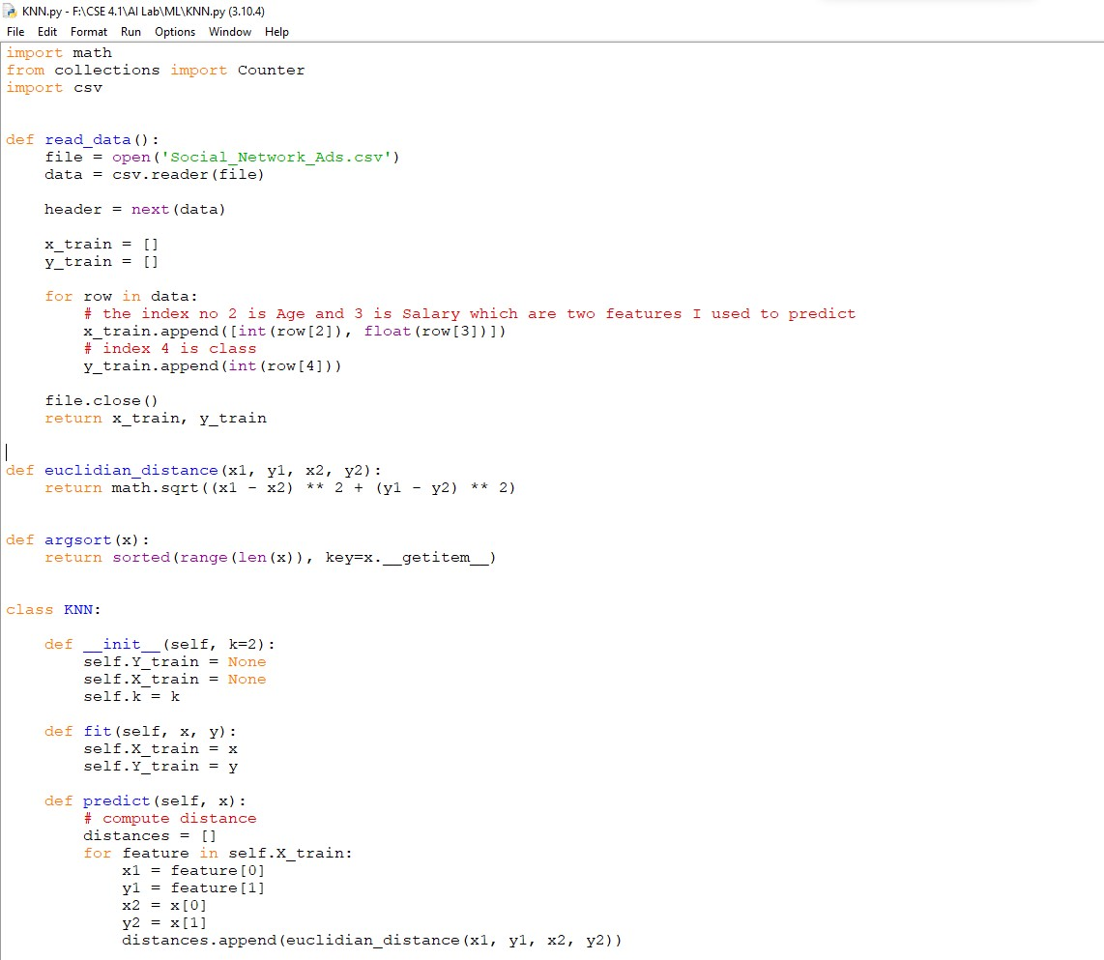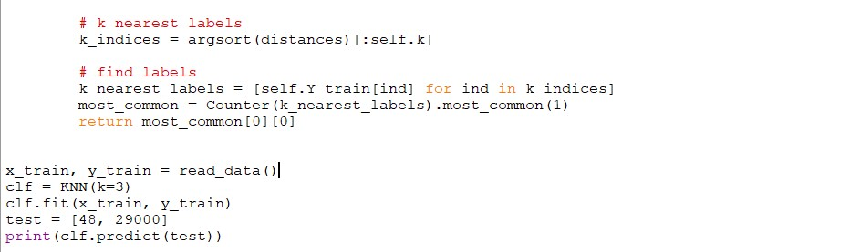

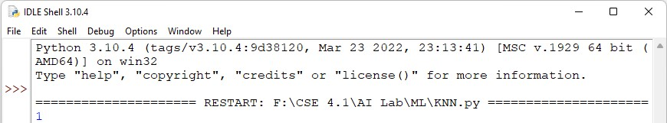

**Question 2**: Implement K Means Clustering algorithm in Python.

**Solution:**

Python Code:

**import** csv  
**import** random  
**import** math  
**import** matplotlib.pyplot **as** plt  
  
**def** euclidian_distance(x1, y1, x2, y2):  
**return** math.sqrt((x1 - x2) ** 2 + (y1 - y2) ** 2)  
  
**def** calc_mean(data_points):  
sumx = 0  
sumy = 0  
n = len(data_points)  
**for** x **in** data_points:  
sumx = sumx + x[0]  
sumy = sumy + x[1]  
  
**return** [sumx / n, sumy / n]  
  
**class** Kmean:  
**def** __init__(self, k=1, max_itr=1000):  
self.k = k  
self.centroid = **None**self.max_itr = max_itr  
  
**def** fit(self, x):  
rand_ind = random.sample(range(0, len(x)), self.k)  
self.centroid = [x[ind] **for** ind **in** rand_ind]  
  
**for** i **in** range(0, self.max_itr):  
clusters = self.assign_cluster(x)  
prev_centroid = self.centroid  
self.centroid = self.move_centroid(x, clusters)  
**if** self.centroid == prev_centroid:  
**break  
return** clusters  
  
**def** assign_cluster(self, x):  
distance = []  
clusters = []  
**for** row **in** x:  
**for** centroid **in** self.centroid:  
x1 = row[0]  
y1 = row[1]  
  
x2 = centroid[0]  
y2 = centroid[1]  
distance.append(euclidian_distance(x1, y1, x2, y2))  
min_distance = min(distance)  
min_ind = distance.index(min_distance)  
clusters.append(min_ind)  
distance.clear()  
**return** clusters  
  
**def** move_centroid(self, x, clusters):  
unique_clusters = list(set(clusters))  
new_centroid = []  
**for** cluster **in** unique_clusters:  
temp = []  
**for** ind **in** range(0, len(clusters)):  
**if** cluster == clusters[ind]:  
temp.append(x[ind])  
new_centroid.append(calc_mean(temp))  
**return** new_centroid  
  
**def** read_csv():  
file = open(**'custering.csv'**)  
data = csv.reader(file)  
  
header = next(data)  
x_train = []  
**for** row **in** data:  
  
x_train.append([float(row[0]), float(row[1])])  
  
file.close()  
**return** x_train  
  
x_train = read_csv()  
kmean = Kmean(k=3)  
y_mean = kmean.fit(x_train)  
*# print(y_mean)*t1 = []  
t2 = []  
t3 = []  
  
**for** x **in** range(0, 2):  
**for** ind **in** range(0, len(x_train)):  
**if** y_mean[ind] == x:  
**if** x == 0:  
t1.append(x_train[ind])  
**elif** x == 1:  
t2.append(x_train[ind])  
**else**:  
t3.append(x_train[ind])  
  
*# plt.scatter([p[0] for p in t1], [p[1] for p in t1], color='green')  
# plt.scatter([p[0] for p in t2], [p[1] for p in t2], color='red')  
# plt.scatter([p[0] for p in t3], [p[1] for p in t3], color='blue')  
  
# plt.show()*print(**"Cluster: 0"**)  
print(t1)  
print(**"Cluster: 1"**)  
print(t2)  
print(**"Cluster: 2"**);  
print(t3)

